Letter of Intent

Phillips 66 Branded Supply Agreement

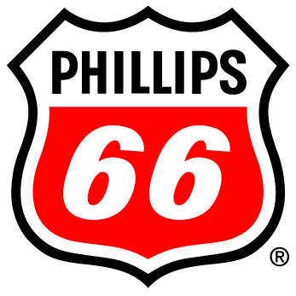

between

Customer Site,

the Dealer

the Jobber

Originally Proposed 6-6-2025

Valid until 7-6-2025

Introduction

Better Day Energy is a fuel distributor, (the “Jobber”) based in Hillsboro, MO and doing business in Missouri. _________________ is a fuel dealer operating a retail convenience store located at ___________________________ (the “Dealer”).

Proposal

Better Day Energy proposes to provide **brand imaging funds**, **consulting services**, and **fuel supply and delivery services** in exchange for an exclusive **10-year fuel supply agreement** with the Dealer to purchase __________ gallons gasoline and ____________ gallons diesel per month.

Value

Better Day Energy offers a number of programs which create value for our customers including **competitive fuel pricing**, **low credit card transaction fees**, world-recognized **Phillips 66 Brand** image, **fuel industry expertise** providing on-going support to your station’s operations as increasing and changing Federal, State, and Local regulations impact the way you do business.

Incentives

**Image Funding** for Phillips 66 Branded fascia, signs, LED halo lighting, main ID sign faces, and digital product pricing board for fuel pricing. **Valued $85,000 per site**

**Incentive Funding** based on contract performance. **Valued $45,000 for Kincaid**

**Valued $100,000 for Mt Sterling**

**Rebate compliant fuel supply** and monthly reporting to state and federal fuel programs. **Valued $216,000**

Project Details and Timeline

Critical to the success of this project and securing the available incentive money to realize the full value of this proposal is adherence to the project timeline and required qualifying activities.

1. Execute Fuel Supply Agreement
2. Convert Credit Cards and begin B11/E10 fuel supply
3. Solicit existing supplier for transfer
4. Secure site transfer and/or debrand
5. Execute project and imaging contract documents with vendors
6. Install Canopy if required.
7. Conoco Phillips Imaging Project
   1. Image canopy with fascia, signs, and LED halo lighting.
   2. Replace main ID sign faces with brand signs.
   3. Install new digital product pricing board for gasoline.
8. Submit final invoices, proof of payment, and evidence of project completion to brand for project reimbursements

Acceptance of Letter of Intent as proposed:

Dealer, Better Day Energy LLC

By: By:

Name: Name:

Title: Title:

Date: Date: